# Conflict management

In a conflict there are different expectations, interests, opinions, goals or settings of people, organisations, social groups or even states.

Conflicts can happen in every organisation. Conflicts may arise in all economic sectors, like companies, governments, authorities, between states or private people. A conflict emerges when interests, facts, goals of ecomonic sectors differentiate from each other or cannot solve these issues / conflicts. As a result, there are interests conflicts, opinions conflicts and goal conflicts. Conflicts are not always visible to the people who have the conflict. It is also possible that the conflict is just hovering latent which means that the participants are not noticing it.



As a result, statement nr 1 is not true, because conflicts can also exist if nobody knows.

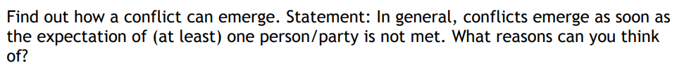

Moreover, answering the second statement: Conflicts emerge when one person has the feeling that their interest, opinion or goals are being ignored (Can also be unaware of). A reason could be that humans always want to have a comfort life, which they expect to have.



The four-sides model describes communication. We can communicate on four layers which don’t have the same emphasis. The four sides of the message are [fact](https://en.wikipedia.org/wiki/Fact), [self-disclosure](https://en.wikipedia.org/wiki/Self-disclosure), [Social relationship](https://en.wikipedia.org/wiki/Social_relationship) between sender and receiver, and wish or [want](https://en.wikipedia.org/wiki/Want).

To answer the question: a conflict can emerge when the sender intends to send the message on a different layer than the receiver receives. For example, the sender explanans something about him and the receiver thinks that’s an actual fact.



If some expectations are not met, a conflict emerges. However, this can also happen with roles. If different individuals have different expectations about a role, one party could for example think that they have to do this although they don’t have to.

Moreover, conflicts is strongly related with roles because every role brings expectations and conflicts emerge from unmet expectations.

## Dealing with conflicts

Ein Bild, das Text enthält.

Ignoring has the big problem that the conflict will never be solved because you are not willing to take about the conflict. This isn’t very effective for the relation between the two parties. However, maybe one party feels better because they just ignore the problem and live with it.

Problem-orientation has an advantage over ignoring because the parties are seeing the conflict. This doesn’t mean that they want to solve the conflict. However, sooner or later the conflict could be solved because they realize that this conflict is not necessary.

The best way to solve a conflict is probably the solution-orientation because the parties want to solve their conflict and are actively willing to discuss the problem.

Reactions to conflicts

Conflicts can be dealt with

* flight | arrangement | WIN-LOSE
* fight | arrangement | WIN-LOSE / LOSE-LOSE
* subordinate | arrangement | WIN-LOSE
* delegate | arrangement / solution | WIN-WIN / WIN-LOSE
* compromise | solution | WIN-WIN / WIN-LOSE
* consensus | solution | WIN-WIN

Classification of conflicts according to Glasl (A)

A possibility to classify conflicts has been created by the Austrian Friedrich Glasl.

Ein Bild, das Text enthält.

1. A conflict emerges of some **tension** between to participants.
2. Both parties want the other party to **convince that their opinion** is the right one.
3. The parties loose the feeling and verbal conversation is shut down. The **pressure** rises.
4. The definition of the win changes: You win by **making the other party loose**. The conflict itself isn’t the main fucus at this point.
5. The opponent should be **destroyed**. Loss of face means loss of their **moral credibility** (Glaubenswürdigkeit).
6. The parties try to control the situation through **threats**. Claims, sanctions, and sanction potential are used to symbolise the **power** of one party.
7. The loss of the opponent **should be greater** than yourself’s. The opponent is no longer seen as a human.
8. The opponent is to be destroyed with **extermination actions**.
9. From here on, you calculate **your own destruction** in order to defeat your opponent.

* find out why the strategy to solve a conflict depends on the level of the conflict.

On the first level the target of the strategy is that both parties win because it is possible in this level. In the “win-lose” level the strategy has to consider that it is no longer possible that both parties win. The strategy changes to: The least amount of damage is the best solution. In the last level both parties will lose, so the strategy is similar to level 2: Th less damage for both sides the better.

* Find for each level a realistic example from public media (newspaper, …)
  + LOSE-LOSE: Ukraine-Russia-War
  + WIN-LOSE: Donald Trump wants to win by making Biden loose
  + WIN-WIN: Elon Musk builds rockets, which nowadays often land safely

Dynamics of Conflicts by Karpman (A)

This is the Drama-Triangle from Karpman:

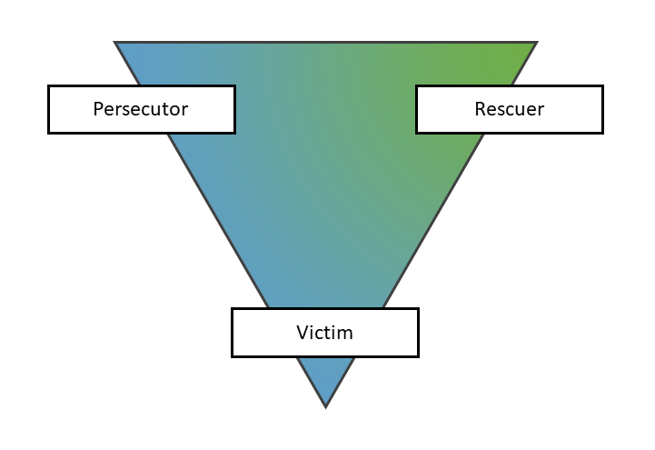

In this model are three roles: the Persecutor (der Täter), the Rescuer (der Retter) and the Victim (das Opfer). This model is often used in psychology to determine how big the ego of the person is.

## Role play

The participants are not the roles, they play the roles! The roles can also change between the people participating. For example: Person A boxes Person B, Person C comes to help Person B. In this situation Person A is the persecutor, Person B the victim and Person C the rescuer. However, if Person A and Person B know that this boxing is just for fun, Person A gets the victim to the persecutor C. And if Person B gets the persecutor, Person A also gets the persecutor. Now Person C gets the victim, however, Person C could also be the persecutor.

This game can also be played by two or even one people / person. If one person plays the drama-triangle, the inner dialogue plays the different roles.

The drama triangle describes a basic pattern of human action/reaction and the associated behaviours. It serves to regulate closeness and distance. This is true on a large scale (war and peace) as well as on a small scale (children's play and everyday relationships). As rescuer and victim, one is often close to each other, from the persecutor one keeps away, and is very close to him in other ways at the same time.

# Personality influences conflicts by Berne (A) - Transactional analysis

Transactional analysis deals with the question of why people feel, think and behave the way they do at that moment. To do this, you analyse interpersonal communication. In transactional analysis, communication is called a transaction.

You assume that every person has three ego states: The parent ego, the adult ego, and the child ego. The ego state that comes to the fore influences how the person experiences a situation and how he acts, thinks and communicates.

## Videos – Transactional analysis [1](https://www.youtube.com/watch?v=nKNyFSLJy6o)

Every human being changes constantly between the three states when communicating: child, adult and parent. The goal should be to find yourself as often as possible in the adult state.

Every state has it’s sites, which are compliant, they are between weak and strong.

The child state feels less entitled than the other person. It follows strategies from their childhood and sees others as more entitled. In this state you react rather with guilt, fear, or aversion. The child state has two sites: the free and the adapted site. Both can be positive and negative. Free, negative: egocentric, wild and inconsiderate. Free, positive: creative, playful, curious. Adapted, positive: assertive, co-operative, accommodating. Adapted, negative: fearful, rebellious, complaint.

The adult state sees everybody as equal and it uses strategies that are spontaneous or context-appropriate. Moreover, it responses objective appraisal.

Last but not least, the parent state sees itself as more capable and intrinsically. Additionally, saying ‘no’ feels cruel or mean for a person in the adult state. There is the controlling site, which has the negative properties: dismissive, autocratic and fault-finding. However, the controlling site can also be positive: constructive, organising, firm. The other site is the nurturing site. It can be positive: caring and supportive; or negative: smothering, overprotective.

People can communicate in a complementary transactions where for example a child state human talks to a parent state human. The conversation is parallel and stable. Otherwise, it is also possible that people talk crossed. For example two parent state humans try to convince the other that he/she is the parent in this situation. The conversation is crossed and unstable. Last but not least, there are split transactions, where the conversation seems to be in a way, it actually isn’t beneath the surface.

## Similarities between drama-triangle and transaction analysis [2](https://www.youtube.com/watch?v=YOqJ4sc9TAc)

Games: Most conversations are games. Like in the drama triangle, the people involved are switching between their roles. Here the people communicating are switching their state (child, adult, parent). These switches are followed by a cross-up, a bit of disorientation. Now come the payoffs, where the people feel what the either wanted or are surprised to feel.

There are different degrees of games: First-degree games: mild, acceptable. Second-degree games: socially unacceptable. Third-degree games: real harm caused. (Fourth-degree games: world stage)

Player A initiates a game with a CON. Player B must accept the CON and reveals their GIMMICK.

GAMES FORMULA: CON + GIMMICK = RESPONSE 🡪 SWITCH 🡪 CROSS-UP 🡪 PAYOFF

Summary: Games can psychologic be analysed with the transaction analysis and the drama triangle.

## Life positions

* Equality position: “I’m OK, You’re OK”
* Depressive position: “I’m not OK, You’re OK”
* Arrogant position: “I’m OK, You’re not OK”
* Futile position: “I’m not OK, You’re not OK”

# Analysing situations (B)

## Teacher asks for huge homework before exam tomorrow

Dialog, teacher and students both in adult state (Glasl: Level 1):

Drama triangle: Teacher persecutor, students: victims:

|  |  |
| --- | --- |
| **Teacher** | **Students** |
| Homework until tomorrow is task 4 on page 128 in the book. You will have to write an essay with around 600 words. | Mr Brown,  Could you please consider given less homework today because we have an exam tomorrow and, as a result, not much time to write this essay. |
| Which exam do you have tomorrow, geography or something important? | The mathematic exam, Mr. |
| Okay, would it be okay, if you get more time to do the homework, let’s say until Monday. | Yeah, I think this would doable. Or does anyone need even more time? |
|  | Ah, could we do next Friday instead, because I’m not at home this weekend? |
| Next Friday I would like to give you the essay back, controlled logically… | So what if we send you the texts until Wednesday per e-mail? |
| Okay, this would be fine for me. | Okay, thank you very much! |
| No problem! |  |

Dialog, teacher in parent state and students in child state (Glasl: Level 4):

Drama triangle: Teacher persecutor, students: victims:

|  |  |
| --- | --- |
| **Teacher** | **Students** |
| Homework until tomorrow is task 4 on page 128 in the book. You will have to write an essay with around 600 words. | Wow,  This is a lot of homework! |
|  | Yeah, we can’t do this in one single day, Mr! |
| I’m sure you will be able to do this. The other class did it, too, last week. And the essays were great. | Please, could you give as more time! |
| I’m sorry, but as far as I know, you only have six hours today, so this should be no problem. Moreover, you need to learn how to get tasks done with time pressure. No more discussion… | Mhhh… |

Dialog, teacher in parent state at first, then in child state and students in parent state (Glasl: Level 2):

Drama triangle: Teacher victim, students: persecutor:

|  |  |
| --- | --- |
| **Teacher** | **Students** |
| Homework until tomorrow is task 4 on page 128 in the book. You will have to write an essay with around 600 words. | Mr Brown,  It is not recommended to give us only one day to finish a 600 words essay. These essays would be more readable if you give as more time to think about the topic. |
| That’s not right, you need to learn how to write an essay in a short time. In the exam you also have two hours. | Speaking about two hours: Tomorrow, we have a 2-hour-test, so I don’t think that everybody would rather do their homework today, instead of learning for math. |
| Oh, I didn’t know that. I could accommodate you by giving you more time. How much time would you all need? | At least two weeks. |
|  | Very funny, Luke. I think one week until next Friday would be enough time. Does anyone need even more than a week? |
|  | No |
|  | Ah, no |
| Okay, then, let’s do it until next Friday. |  |

## The hard egg

<https://htlkrems3500-my.sharepoint.com/personal/f_schneider_htlkrems_at/Documents/Schule/ITPP/ConflictManagement/UE_Frühstücksei.docx>

# Possible ways out; a conflict of my choice (E)

Last year in ITPL we had small conflicts because the graphic designers were sometimes playing other games instead of designing. The problem was that the graphics they designed, weren’t that good. So, the programmers wanted them to improve the bad graphics. Moreover, they had less work than the programmers and instead of helping or improving, they were just playing…

## Solution 1:

Just take the bad graphics and don’t care.

In this case, you have to deal with the conflict yourself. You have to accept that the problem is not a big problem, and you just don’t’ care about the bad graphics. You are the victim, and they are the probably the persecutors. You are the child because you don’t talk about it.

## Solution 2:

Telling the graphic designers that they should rework their graphics.

Here, the problem is now theirs. You are the persecutor, and they are the victims. Maybe the go to someone who is good at designing and get help. This person would be the rescuer. You are the parent, and they are the childrens…

## Solution 3:

Help them designing better graphics.

If the programmers would have had more time, this would be the obvious solution. In this case, nobody is the victim, and nobody persecutes anybody. Both parties are in the adult state.